FAN Foundation,
Who are we?
We transform lives and shape the future by creating safe, loving spaces where children, adolescents, and their families can heal, rebuild relationships, and forge a future full of hope and opportunities.
Since 1964—more than 60 years ago—at FAN Foundation, we have made it our mission
to be the voice and helping hand for those who need us most.
Our purpose is clear and profound: we transform the lives of those who have faced adversity and find in us a refuge—a safe space where they can heal and rebuild their trust in the world.
At the FAN Foundation, we work every day to transform the lives of vulnerable children and adolescents and their families in Colombia. Through comprehensive care programs, psychosocial support, and family strengthening, we create protective environments that generate real opportunities for development.
In Colombia, a child is physically, psychologically, or sexually abused every 12 minutes.
Office of the Attorney General of the Nation, 2023
Let’s not turn our backs on this situation any longer.

Shaping the future means transforming the present. It means sowing opportunities, restoring trust, and strengthening the bonds that sustain every child and their family. Because behind every girl and boy there is a family that also needs support and guidance.
Every girl, boy, young person, and adult we support, every story we transform, and every family we restore drives us to move forward with even greater strength. We are FAN, a foundation that believes in the magic of connections, the greatness of dreams, and the certainty that every child deserves a present and future filled with love, dignity, and opportunities.
What makes us different and relevant?
We have taken it upon ourselves to forge our own identity in order to actively contribute to the communities where we operate:
We are experts in designing and implementing environments, experiences, and tools to promote and care for mental and emotional health, and to develop the skills of children and adolescents in family, school, and community settings.
We have found in play therapy, art theory, and color theory the most suitable language for bringing about meaningful change in the people we support through each initiative.
We work in partnership with other NGOs in Colombia. Rather than viewing them as competitors, we see each organization as an opportunity to multiply our impact in communities and build collective intelligence.
Demonstration, research, and evaluation are the key strategies for strengthening our social impact in communities; they are part of our new DNA.
Family strengthening is the foundation of everything we do; that is why families play a key role in every initiative we offer to children and adolescents.
What do we do?
The FAN Foundation promotes programs and projects that foster the holistic development of children and their families, strengthening protective environments, emotional well-being, and community support.
+ 380k Children Reached
+ 60 Years of Work
+ 56 Municipalities Served
+ 1,000 Direct Staff Members
Since 1964, we have been working to improve the present lives of thousands of children and adolescents so that their past experiences do not affect their future.
How do we make this possible?
Comprehensive Early Childhood Care
We design meaningful, experiential learning spaces and activities for holistic early childhood development, creating diverse, inclusive, and autonomous environments that promote learning and growth for children up to age 5. Through interactive activities and programs specifically designed for this stage of life, we actively involve families and the community in the educational process, ensuring that the family and sociocultural environment becomes a fundamental pillar of love, care, and protection.
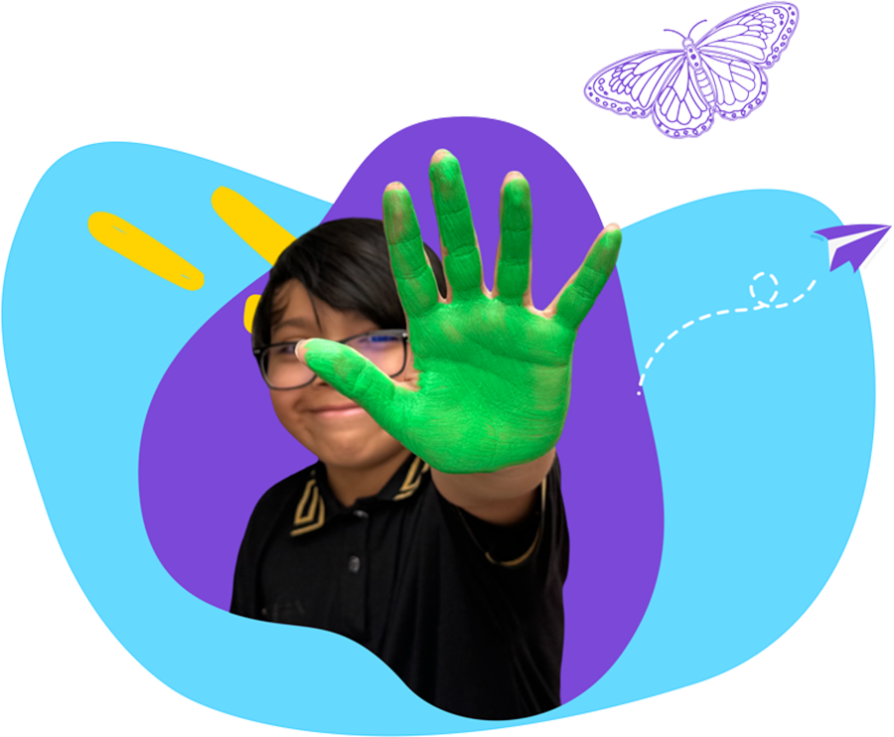

Specialized Care for Victims of Violence
Through “Jugar para Sanar,” we support children, adolescents, and their families in environments designed with symbolism and meaning, where they can reframe their experiences of violence or abuse. In these spaces, trust is restored, attachment bonds are strengthened, and essential capacities such as resilience and life skills are developed.
To schedule an appointment for our “Jugar para Sanar” program, you can call 4480288, extension 6, or the “Jugar para Sanar” Floresta cell phone at 3228619247. If you have a court order, you can email it to solicitudessura@fan.org.co.
Prevention and Promotion
Mental and Emotional Health
We strengthen resilience and protective factors.
We promote human development and psychosocial life skills through play, the languages of art, literature, and color psychology.

We provide people with valuable tools to recognize themselves, connect with themselves, and be more empathetic toward others and their realities.
The results of the EDI assessment show a decrease from 26.27% of children who were behind or at risk of falling behind (entrance test results) to 10.85% (exit test results). This represents a 15.42% reduction in learning delays or the risk of delays and is directly correlated with the quality of early childhood education that FAN Foundation provides at the centers it supports.
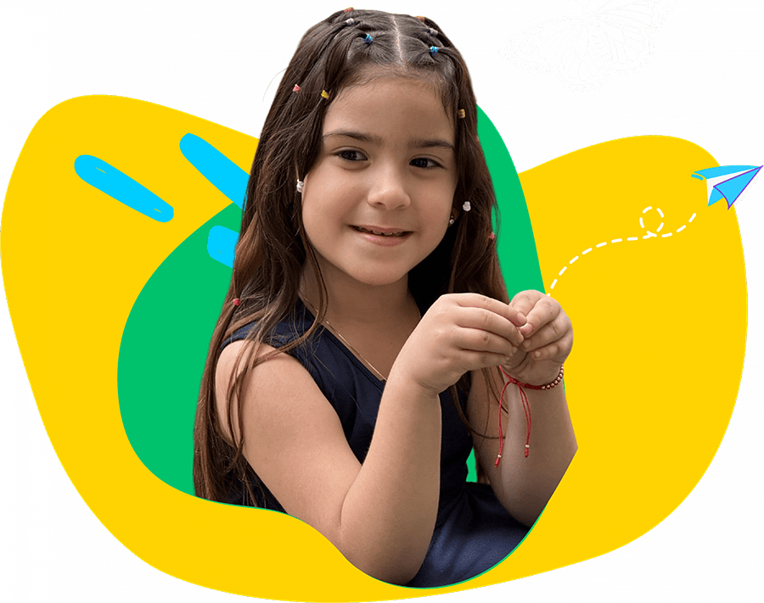

Knowledge Transfer
We share our expertise and experiences. Today, our “Play to Heal” model is in Mexico. Under the name GuardiaNNA, two care centers opened their doors in October 2024—one in Ciudad Juárez and the other in Chihuahua.
Flower Carpet at the Santafé Medellín Shopping Center
For more than a decade, the Santafé Shopping Center in Medellín has donated the Flower Carpet to FAN Foundation, which is installed during the Flower Fair. Through this donation, we’ve launched a social mobilization strategy in which a team of volunteers invites visitors to take a small piece of the carpet in exchange for a voluntary donation.
This initiative not only allows us to raise funds to strengthen our projects but also to raise awareness, rally support, and create shared value around a cause that unites us: protecting and caring for children.

